**Unilever Digital Helpdesk**

**Analytics Services**

**Access Management**

Release Date:

Status: In-Progress

Version 1.0

# **Analytics Services**

These are services requested for analysis and reporting of web data for purposes of understanding and optimizing web usage.

## **1.1 Access Management**

If the user has to Request Access to or Revoke Access for Google Analytics profile or Adobe Reportsuite, the user can raise a request under the SRD ‘Access Management’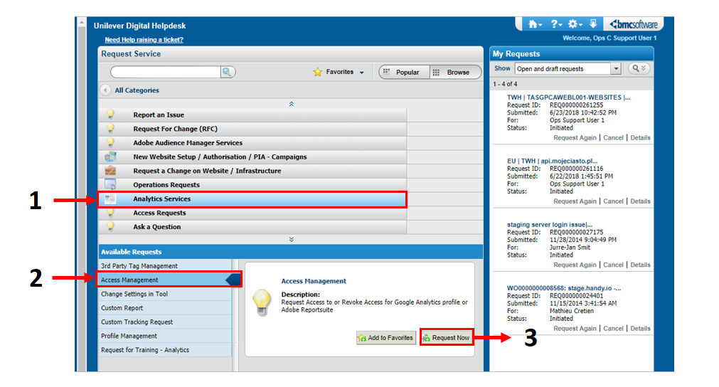

* Select the URL of the site you want access to, the below will be auto populated
  + Brand
  + Country
  + Hosting Platform
* Select whether the environment is ‘UAT’ or ‘Production’
* Once you have completed the mandatory* fields, click ‘Submit’

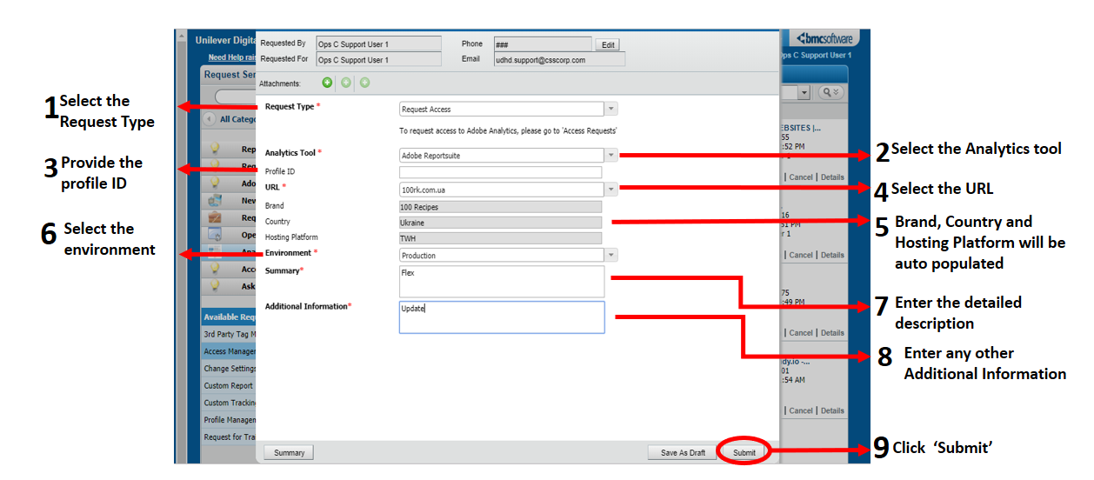

|  |  |
| --- | --- |
| Request Type* | Select the request type   * Request Access * Revoke Access |
| Analytics Tool* | Select the Analytics Tool towards which the request/revoke access is required   * Adobe Reportsuite * Google Analytics Profile |
| Profile ID | Provide the profile ID |
| URL* | Select the URL for which you are requesting the access |
| Environment* | Select the environment in which the website is hosted from the drop down menu   * Production * UAT |
| Description* | Give a detailed description of the request |
| Additional information* | Add the additional information about request/revoke access |